Experiment No. – 7
Date of Performance:
Date of Submission:
Program Execution  (06) | Viva  (02) | Professional Ethics  (02) | Experiment  Total (10) | Sign with Date

Experiment No 7

7.1 Aim: Implementation of Arrays, Pandas and CSV files for some Applications (Any one)Handwritten Digit Recognition System,Image Classification,Image Caption Generator.

7.2 Course Outcome: Illustrate Deep Learning techniques.

7.3 Learning Objectives: Implement the concept of arrays, Pandas, and CSV file operations in Python to preprocess and manage data.

7.4 Requirement: Python 3, NumPy, Pandas, Matplotlib, scikit-learn, Jupyter Notebook / Google Colab environment.

7.5 Related Theory: ​​
Introduction
Data preprocessing and management are fundamental steps in any Machine Learning or Deep Learning pipeline. Before training a model, data must be organized, cleaned, and represented in numerical form suitable for computation. Python provides powerful tools such as NumPy, Pandas, and CSV file handling to accomplish this efficiently. These tools help store, manipulate, and process structured or unstructured datasets, enabling accurate and faster model learning.
When dealing with image-based datasets like the Handwritten Digit Recognition System, raw pixel data must be arranged into arrays, normalized, and saved in suitable formats such as CSV for future use. Each image in such datasets is represented numerically where each pixel’s intensity is stored as a numerical value in an array. Pandas manages this tabular data, while CSV operations allow the dataset to be saved or loaded easily for training models.
1. NumPy Arrays:
NumPy (Numerical Python) is a core library for scientific computing in Python. It provides an efficient data structure called the ndarray (n-dimensional array). Arrays store homogeneous data elements and support vectorized operations, making computations much faster than traditional Python lists. In Deep Learning, arrays are used to store image pixel values, weight matrices, and intermediate outputs.
- Key operations: array creation, reshaping, slicing, element-wise computation, normalization, and matrix multiplication.
- Example: converting pixel data into a 2D array (e.g., 8 × 8 image).
2. Pandas DataFrames:
Pandas is a high-level data manipulation and analysis library built on top of NumPy. The DataFrame is its main structure, functioning like a table with labeled rows and columns. Pandas allows easy handling of missing values, filtering, grouping, and integration with CSV files. It is especially useful for preprocessing large datasets before applying Deep Learning models.
In image-based datasets, Pandas stores pixel data as features (columns) and corresponding class labels as targets. This helps in managing both features and outputs together in a structured form.
3. CSV File Operations:
CSV (Comma-Separated Values) is one of the simplest formats to store tabular data. Python provides built-in and Pandas methods to read from and write to CSV files. In ML workflows, CSV files store preprocessed datasets, allowing easy sharing and reusability.
Typical operations include:
- pd.read_csv() – to read a CSV file into a DataFrame.
- DataFrame.to_csv() – to export processed data.
These functions are essential for data import/export between preprocessing and model-training stages.
4. Handwritten Digit Recognition System:
This system identifies numeric digits (0–9) from images. The scikit-learn “digits” dataset contains 1797 samples, each represented as an 8 × 8 array of pixel intensities (0–16). Every row corresponds to one image flattened into 64 features.
Steps involved:
- Load dataset using load_digits() from sklearn.
- Convert data into a Pandas DataFrame.
- Normalize pixel values (divide by maximum value).
- Store the processed data into a CSV file.
- Reload and visualize a sample image using Matplotlib.
Mathematical Representation / Formula
For normalization of pixel intensity values:
$X_{normalized} = \frac{Xmax}{X}$
where XX is the original pixel value matrix and XmaxXmax​ is the maximum possible pixel value (e.g., 16 for 8 × 8 digit images).
Normalization brings all values into the [0, 1] range, ensuring uniform feature scaling and faster model convergence.
Significance
- Efficiency: NumPy and Pandas handle large numerical datasets faster than traditional Python structures.
- Reusability: CSV files enable dataset portability across systems and tools.
- Scalability: Easy to extend preprocessing workflows to larger datasets such as MNIST.
- Practical Use: Forms the first step in building Deep Learning systems for classification, detection, or generation.
7.6 Procedure:
Load the handwritten digits dataset, preprocess it using NumPy and Pandas, perform CSV read/write operations, and visualize one image sample.

7.7 Program and Output:
Handwritten Digit Recognition (Data Preprocessing) Using Pandas, NumPy and CSV Operations
Setup for google colab
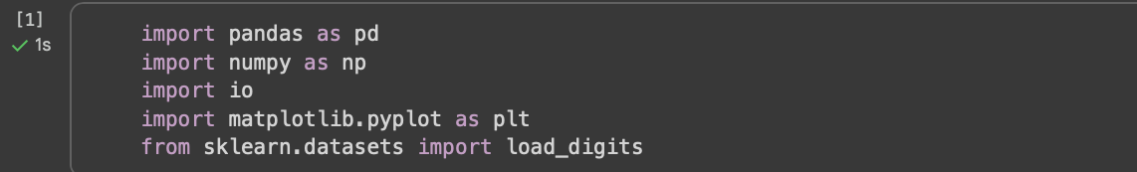
1. Simulate or Load dataset
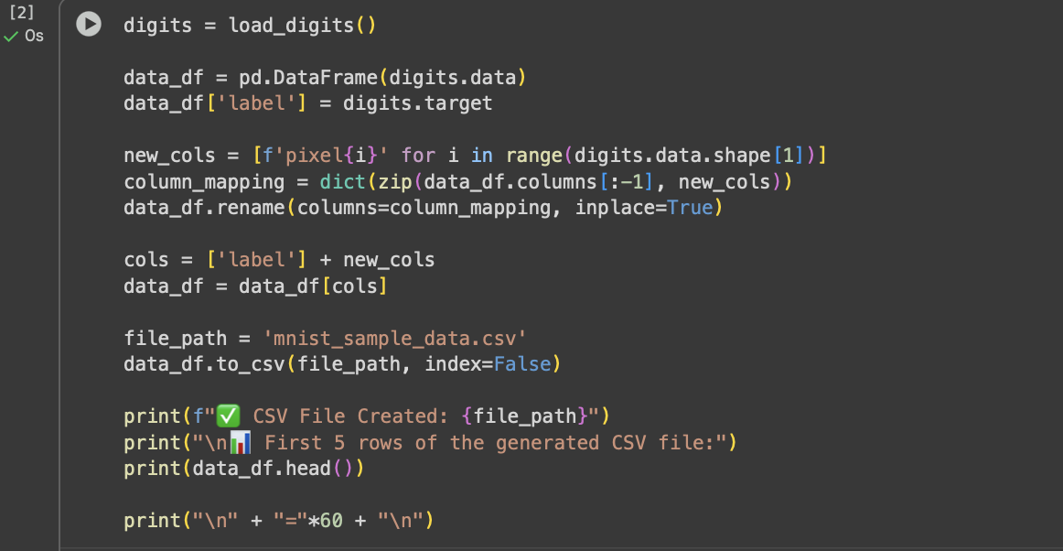
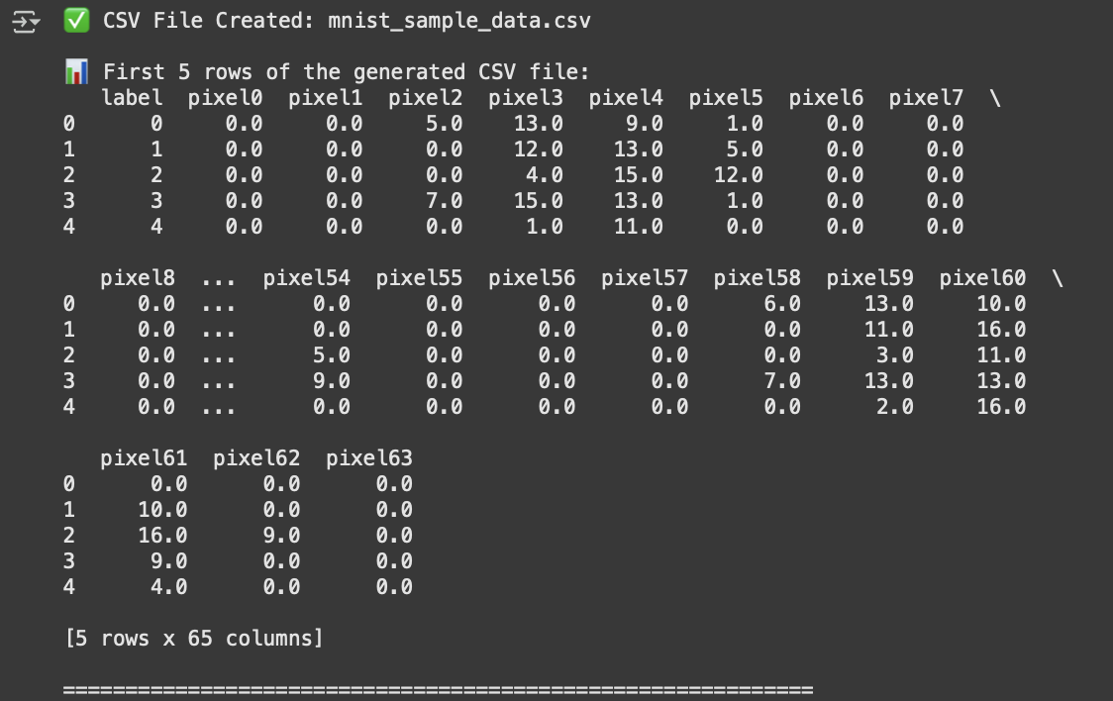
2. Load Data from CSV into Pandas DataFrame
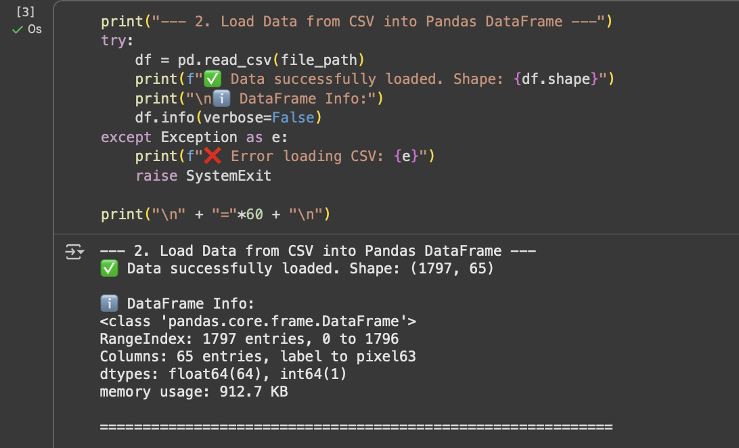

3. Pandas Data Management and Preprocessing
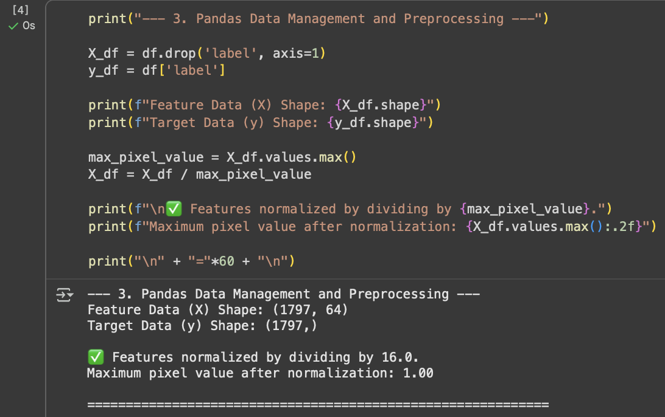

4. Conversion to NumPy Arrays
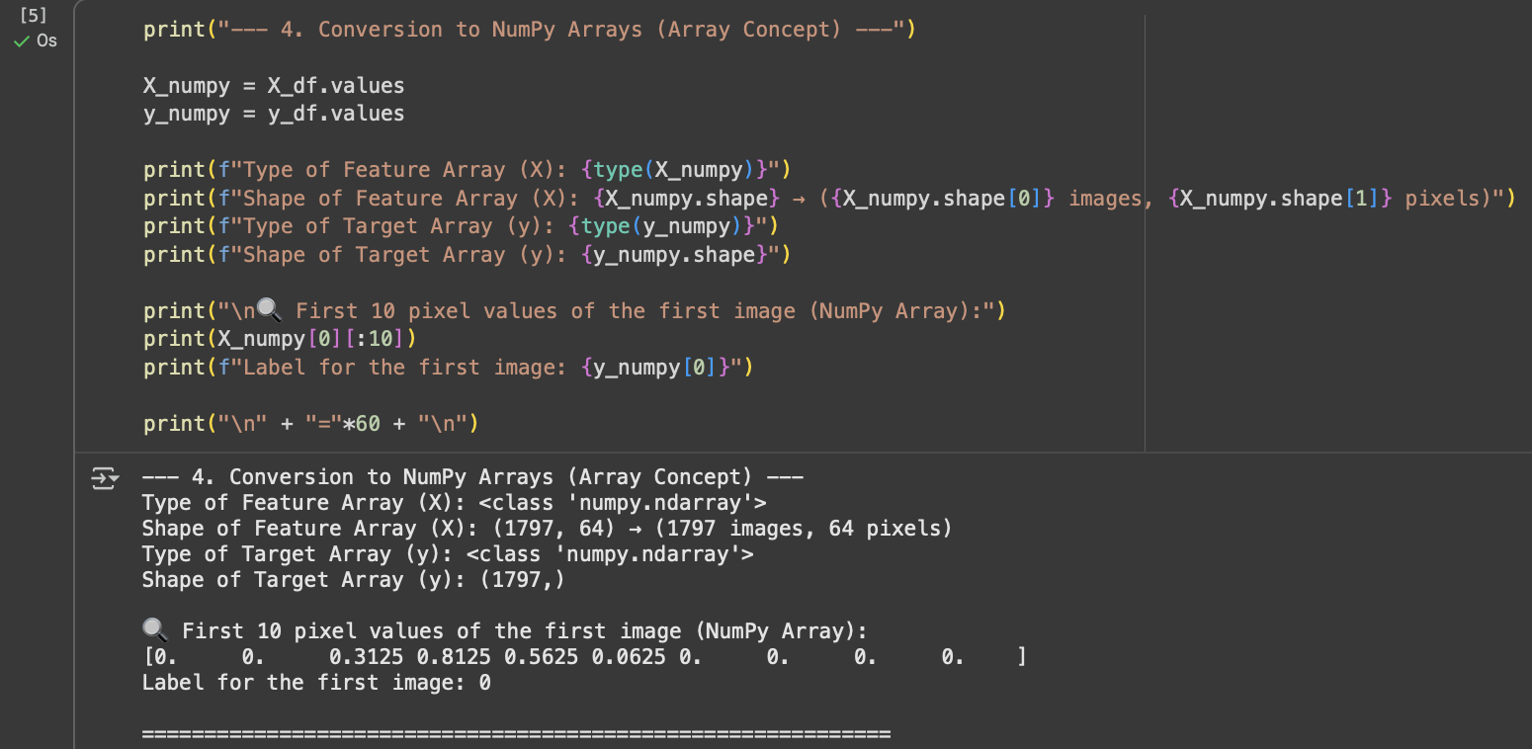

5. NumPy Array Operations(Reshaping)
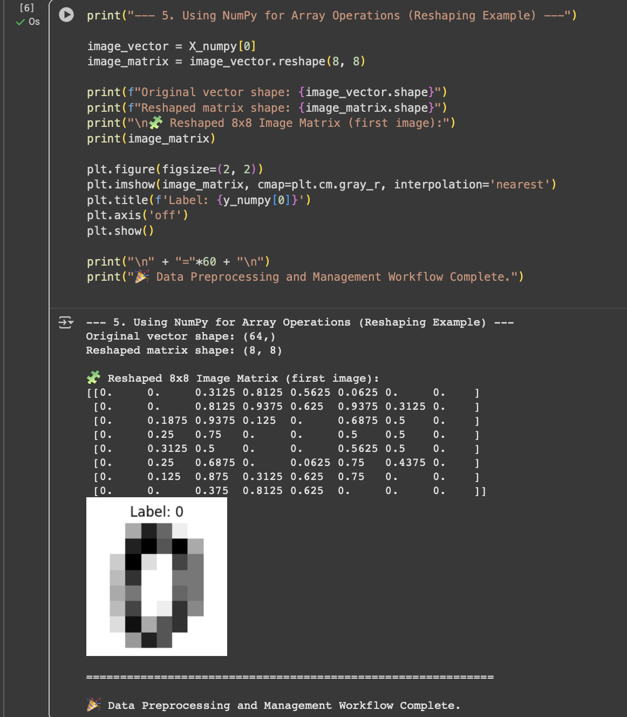

7.8 Conclusion:
Through this experiment, we understood how to implement arrays, Pandas DataFrames, and CSV operations in Python for data preprocessing and management. We learned to convert image data into numerical arrays, normalize pixel values, and store or retrieve datasets efficiently, forming the foundational step in Deep Learning applications such as handwritten digit recognition.

7.9 Questions:

- Why is normalization important before training a model?
Normalization ensures all features have a similar scale, improving model accuracy, convergence speed, and stability during training.

- What are the advantages of using Pandas DataFrames over NumPy arrays?
Pandas DataFrames offer labeled columns, easier data manipulation, handling of missing values, and better integration with data analysis tools.

- How does CSV file handling help in data preprocessing workflows?
CSV handling allows easy import, export, and manipulation of large datasets, making it simple to clean, transform, and prepare data for modeling.

- Explain how image data can be represented as arrays.
Images are stored as multi-dimensional arrays where each pixel’s intensity (RGB or grayscale) is represented by numerical values.

- Which Python libraries are essential for implementing data preprocessing in Deep Learning?
Essential libraries include NumPy, Pandas, scikit-learn, TensorFlow, Keras, and OpenCV.

